Rocket Flight Trajectory Simulator
A 1-DOF MATLAB flight model with stability analysis, validated against OpenRocket
Jonathan Jacob Ajith, Mechanical Engineering

Summary
I built a rocket flight simulator in MATLAB that models a rocket's full vertical flight, from launch through powered ascent, burnout, coast, apogee, and parachute recovery. It is built on Newton's second law, integrated numerically with ode45, and includes a thrust-curve and motor-classification model, an altitude-dependent atmosphere, drag, and a Barrowman static-stability check. I then used the simulator to run a motor-selection study, and validated it against OpenRocket for the same rocket and an AeroTech H165R motor, my predicted maximum velocity agreed with OpenRocket within about 6%.

What it models
The simulator treats the rocket as a point mass moving vertically (one degree of freedom). At each instant it computes the net force , thrust minus weight minus drag, and integrates the resulting acceleration to track altitude, velocity, and mass over time. Key elements:
- Thrust model: a thrust curve with an ignition spike and burnout taper, integrated to total impulse and mapped to a motor class (A, B, C…).
- Atmosphere: air density falls exponentially with altitude, so drag weakens as the rocket climbs.
- Drag: a velocity-opposing drag force, with separate coefficients for the clean ascent and the deployed parachute.
- Recovery: a two-phase integration that deploys the parachute shortly after apogee, using ode45 events to pin apogee and landing exactly.
- Stability: a Barrowman estimate of the center of pressure, compared to the center of gravity, reported as static margin in calibers.

Key results
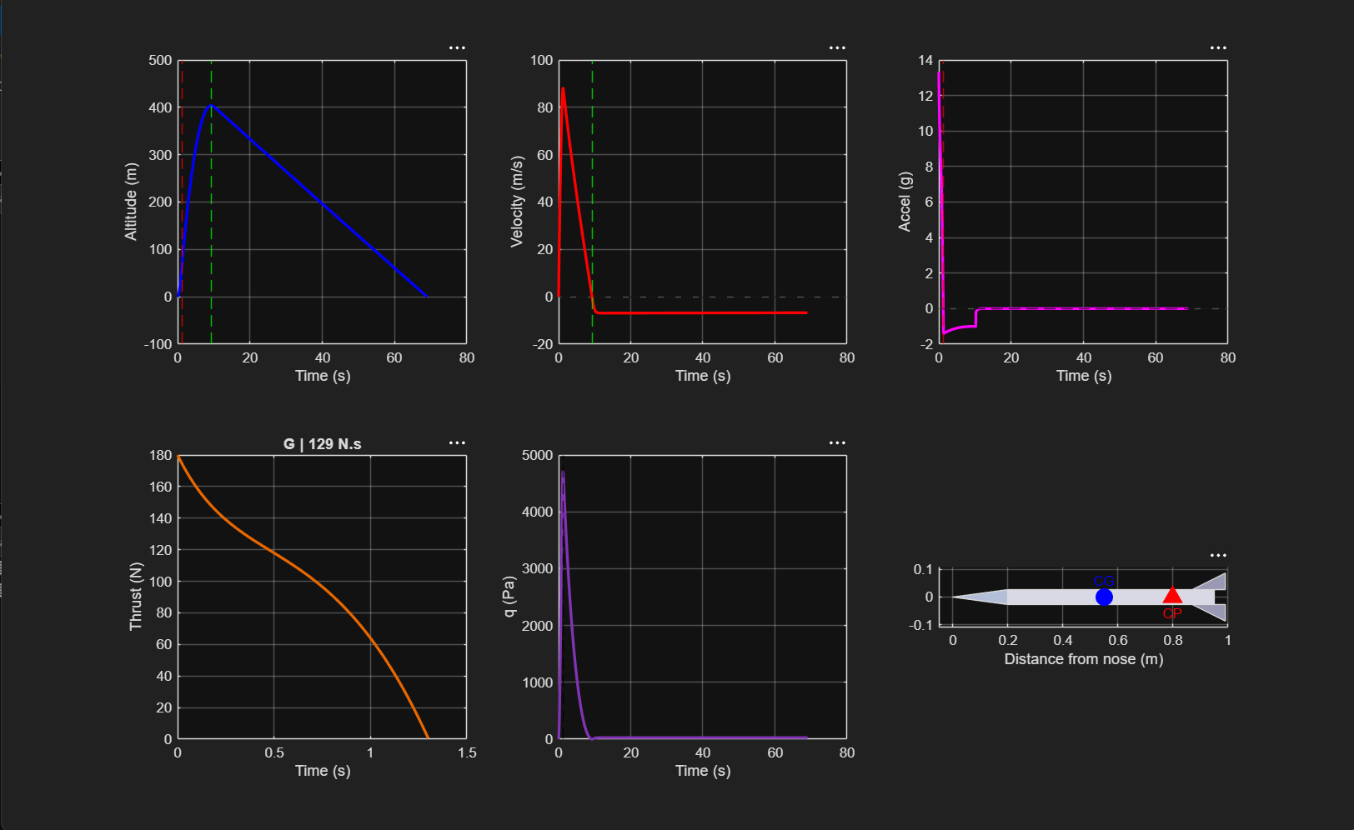
For the baseline rocket and motor, the simulator produces a flight summary, six analysis plots (altitude, velocity, acceleration, thrust curve, dynamic pressure, and a stability diagram), and a launch-to-landing animation. It also reports max-Q (the peak aerodynamic load, which sizes the airframe) and the static margin.
Fig 1: Flight profile for the baseline rocket, G-class motor

Motor-selection study
Because the simulation is structured as a reusable function, I swept it across a range of candidate motors to find the one that best meets a target apogee while keeping the liftoff thrust-to-weight ratio safe (above 5:1). Small motors are safe to handle but undershoot the target; large motors overshoot and pull high accelerations; the study identifies the motor that balances both.
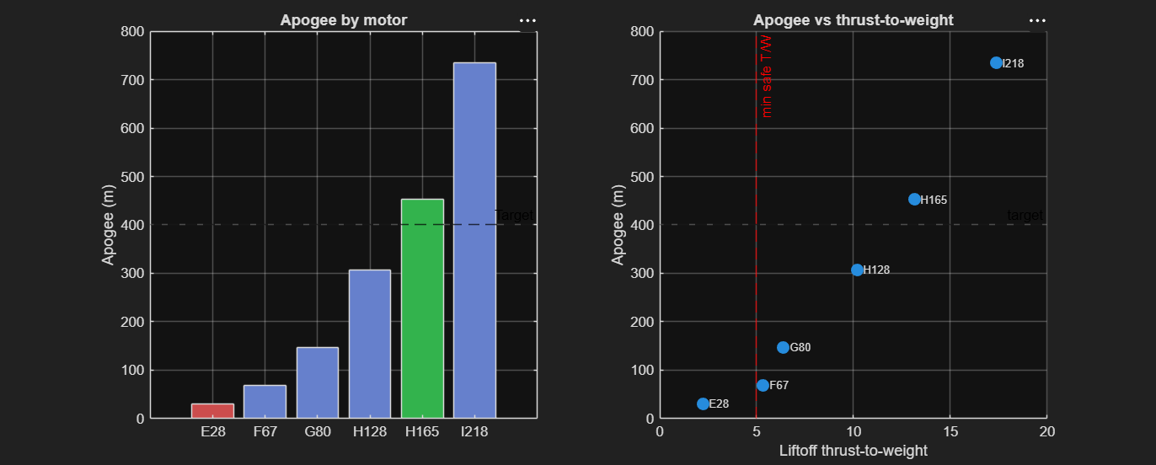

Fig 2: Apogee and thrust-to-weight for six candidate motors. The H165 best fits the 400 m target

Validation against OpenRocket
To check the model, I rebuilt the same rocket in OpenRocket with an AeroTech H165R motor and compared the two. I matched the total impulse to the real motor (the quantity that most directly drives apogee), then compared the three key flight metrics:
Metric | This sim | OpenRocket | Difference
Apogee (m) | 542 | 445 | +21.7%
Max velocity (m/s) | 109 | 103 | +5.6%
Max acceleration (g) | 19.4 | 12.8 | +50.9%
Total impulse (N·s) | 165 | 161 | +2.5%
Maximum velocity matched within about 6%, and total impulse within 3%. Apogee and peak acceleration both ran higher, and consistently so, which points to a single, explainable cause rather than random error. My model uses a fixed drag coefficient, whereas OpenRocket uses a more detailed Mach-dependent drag model, mine therefore under-predicts drag at high speed, letting the rocket coast higher and reach a greater apogee. The high peak acceleration reflects my synthetic thrust curve front-loading the burn more sharply than the real motor. Both discrepancies are consistent with the simplifications I deliberately made, and they bound the accuracy of the approach.
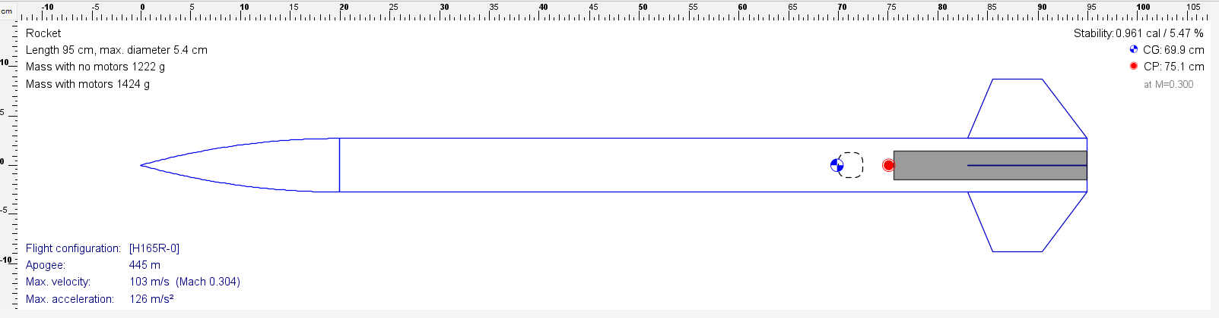
Fig 3: OpenRocket reference: same rocket, AeroTech H165R motor.

Limitations and next steps
- 1-DOF only: vertical flight, so no wind, off-vertical launch, or weathercocking.
- Fixed drag coefficient rather than a Mach-dependent one — the main source of the apogee discrepancy above.
- Synthetic thrust curve; using real .eng motor data from thrustcurve.org would improve the acceleration match.
- Stability uses an estimated center of gravity; real CAD mass properties would make the static margin exact.
Natural next steps are to import real thrust-curve data, add a Mach-dependent drag model, and feed in CAD-derived mass properties, each of which would tighten the agreement with OpenRocket.

Code
The project is organized as modular MATLAB files: define_rocket.m (parameters), simulate_flight.m (the physics engine), rocket_trajectory_simulator.m (single-flight run + plots), and motor_selection_study.m (the design sweep). https://github.com/jonathanajith21/rocket-trajcetory-sim

